Project Design Phase
Solution Architecture

Date | 15 February 2025
Team ID | LTVIP2026TMIDS65594
Project Name | Educational Organization Using ServiceNow
Maximum Marks | 4 Marks

Solution Architecture:
Solution architecture is a complex process – with many sub-processes – that bridges the gap between business problems and technology solutions. Its goals are to:
- Find the best tech solution to solve existing business problems.
- Describe the structure, characteristics, behavior, and other aspects of the software to project stakeholders.
- Define features, development phases, and solution requirements.
- Provide specifications according to which the solution is defined, managed, and delivered.

Example - Solution Architecture Diagram:

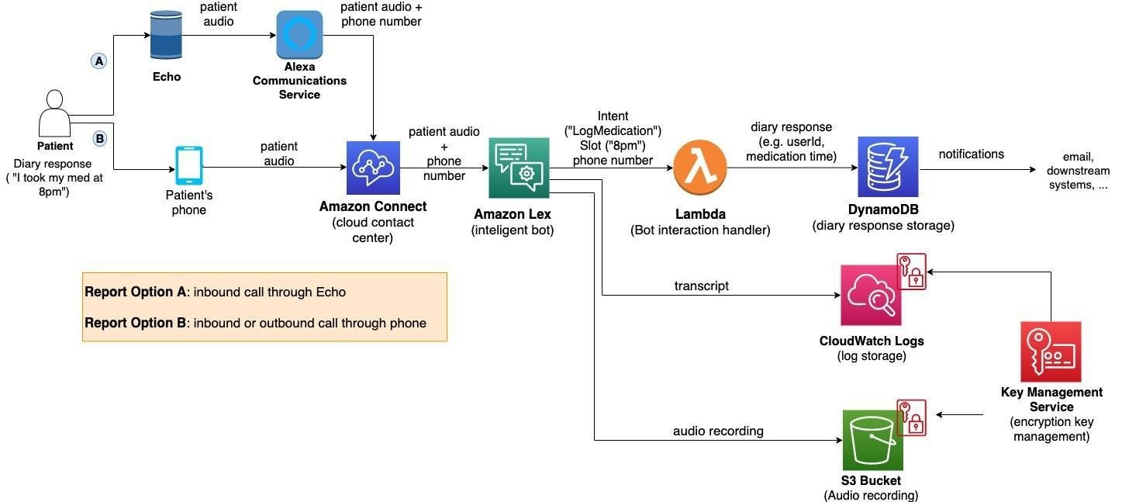
Figure 1: Architecture and data flow of the voice patient diary sample application

1. Presentation Layer (User Interface)
- Web interface for students, teachers, and administrators.
- Provides login, registration, dashboard, and service request forms.
- Technologies: ServiceNow Portal, HTML, CSS, JavaScript.

2. Application Layer (Business Logic)
- Handles workflow automation and data processing.
- Manages student records, course details, service requests, and notifications.
- Provides role-based access for students, teachers, and administrators.
- Technologies: ServiceNow Platform, Workflow Engine, Server-side scripting.

3. Data Layer (Database)
- Stores student information, course data, results, and service requests.
- Ensures secure and reliable data storage.
- Technology: ServiceNow Cloud Database.

🔹 Data Flow
- User submits request through web interface.
- Application processes request using workflow logic.
- Data is stored or retrieved from database.
- System sends response or notification to user.

🔹 Key Features of Architecture
- Cloud-based deployment
- Secure data management
- Scalable system design
- Workflow automation
- Real-time notification support

Reference: https://aws.amazon.com/blogs/industries/voice-applications-in-clinical-research-powered-by-ai-on-aws-part-1-architecture-and-design-considerations/

